**Test plan and reports:**

Suitable unit tests defined & Suitable integration tests defined

□ Database construction in stage of realisation and test

Test preparation, realisation, integrated test, system test and activities for writing a guideline are performed in the realisation and test stage. The test plan is written through test preparation activities, and the design on the component test is carried out. The component and system are realised through realisation activities, and the server component is linked by realising the user interface. If its realisation is complete, the integrated test and system test are executed, and its guideline is written. The following figure and table show a general procedure of the realisation and test stages following PMBOK Guide(2021).

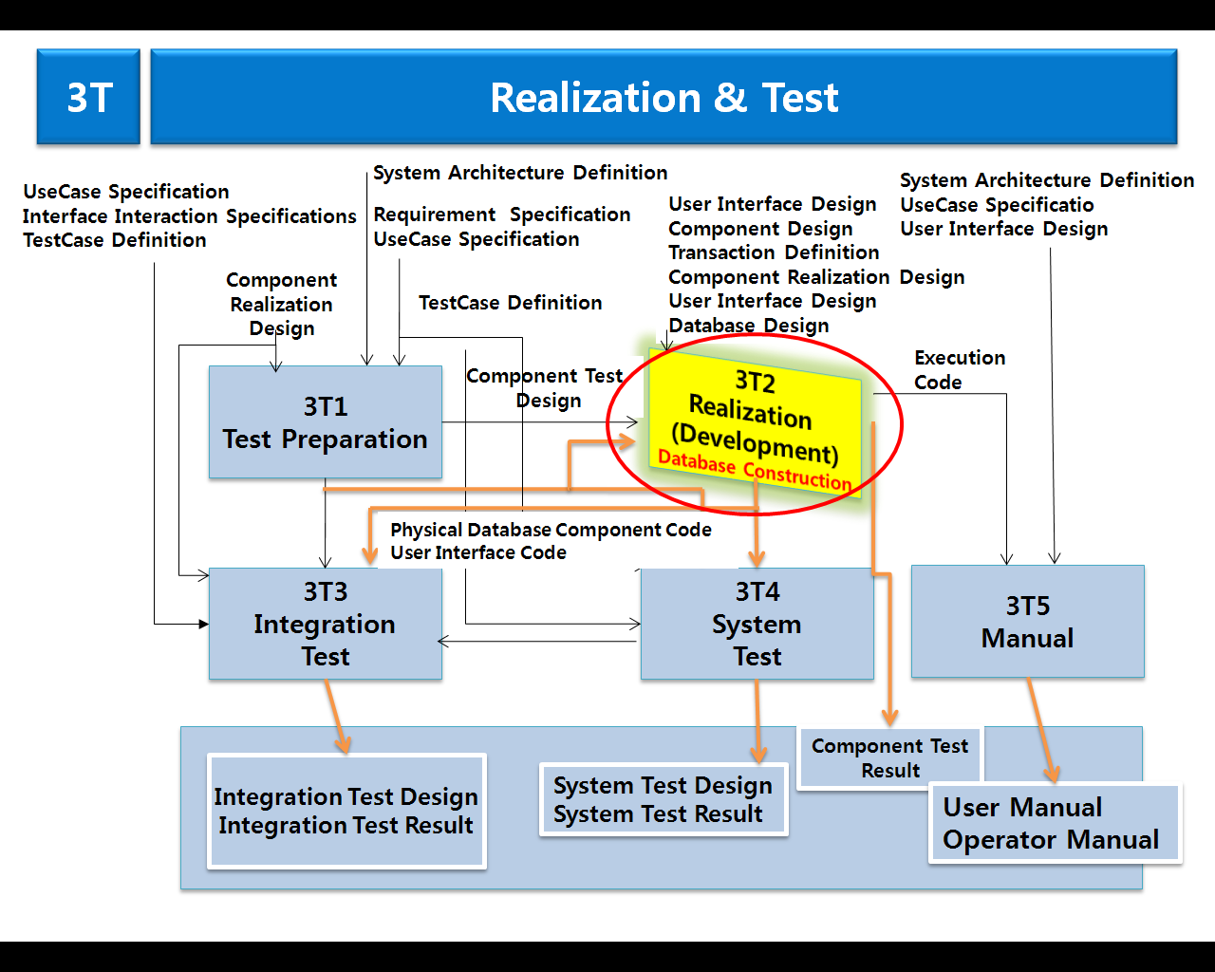

Figure 1. Procedure of Realisation & Test

The following table is tested through several steps as shown in the figure above.

Table 1. Realisation and Test Product

|  |  |  |
| --- | --- | --- |
| **Stage** | **Activities** | **Product** |
| Realisation and   Test | Test Preparation | • Test Plan  • Component Test Design Documents |
| Realisation | • Physical Database  • Component Code  • Component Test Result Report |
| Integrated Test | • Integrated Test Design Documents  • Integrated Test Result Report |
| System Test | • System Test Design Documents  • System Test Result Report |
| Writing of guideline | • User Guideline  • Operator Guideline |

□ In the procedure suggested in Fig. 1, the database has structure that the web-based data on populatin is collected to the integrated center, and also, a system is constructed. For this, the work defining the logic of and physical model of data is already executed in the database design activities, and the logic data model and physical data model being calculated from these activities become factors consisting of data architecture.

Figure 2. System process

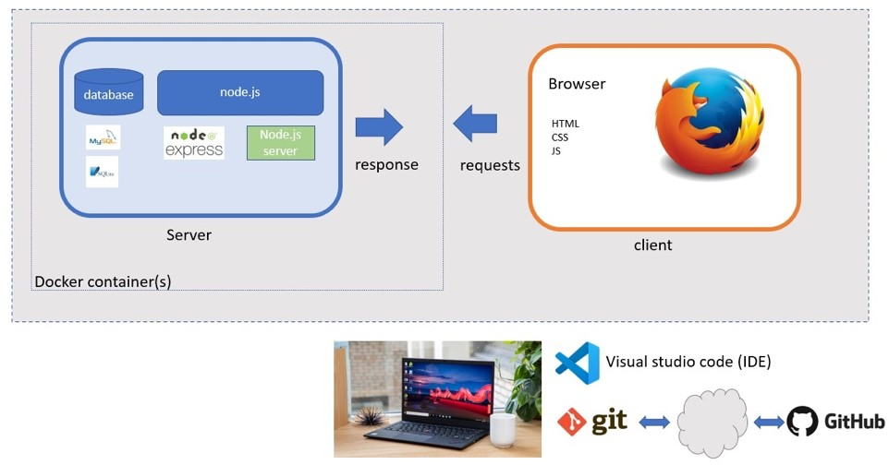

□ Component Realisation & User Interface Realisation

○ Principles for realisation: Combining reusable website outcomes

* In order to prevent redundant investment in this project building, the modules that exist in this project are identified, shared, and reused.
* The changed realisation and test of the website (‘The last chance’ project) goes through the same process as development software.
* The same items and similar items are identified and so is what should be developed among necessary modules and libraries.
* If a commercial library that has the function of a reusable library exists, a decision should be made regarding which is better between developing a library and purchasing a commercial library.
* The decision is made after analysing the advantages and disadvantages of both choices. When reusable website is selected and used, comparability between various environments is considered for the environment where a processing system will be build.

○ Component Realisation

* The design elements designed on the design stage were realised on this realisation stage.
* The first activity of the realisation stage is to define the realisation models of design elements. That is, the realisation models of the website design elements that were made on the design stage were structured.
* The directory structure and namespace structure of the realisation models were defined and the design elements to be realised were distributed to the development team.
* Developers realised the design elements assigned to them and perform a unit test in due date. After that, they will incorporate the realised designed elements into the system.

○ User Interface Realisation

* First of all, interface realisation is performed on the behavior of each interface that the components from the architecture defining stage realise.
* This is the stage for analysing how design elements realise the responsibilities of user interface behaviors.
* Therefore, interface realisation was performed on each interface that the components realises in order to identify design elements.
* For this, sequence diagram was performed on the behavior of each interface that the components realise and the interaction between the designed elements involved in the component interface realisation was recorded.

□ System Testing

1. System test preparation, realisation, integrated test, system test are performed in the realisation and test stage. The test plan is written through test preparation activities, and the design on the component test is carried out. If its realisation is complete, the integrated test and website system test are executed.

The following figure shows a general procedure of the test stages.

Table 2. Website Test Process and Product

|  |  |  |
| --- | --- | --- |
| **Stage** | **Activities** | **Product** |
| System   Test | Test Preparation | • Test Plan  • Component Test Design Documents |
| Integrated Test | • Integrated Test Design Documents  • Integrated Test Result Report |
| System Test | • System Test Design Documents  • System Test Result Report |

□ System Test Process

1) Prepare an unit test

In order to test the software corresponding to website unit, test items reflect detailed design of the website unit.

Figure 3. Test summary on CircleCI

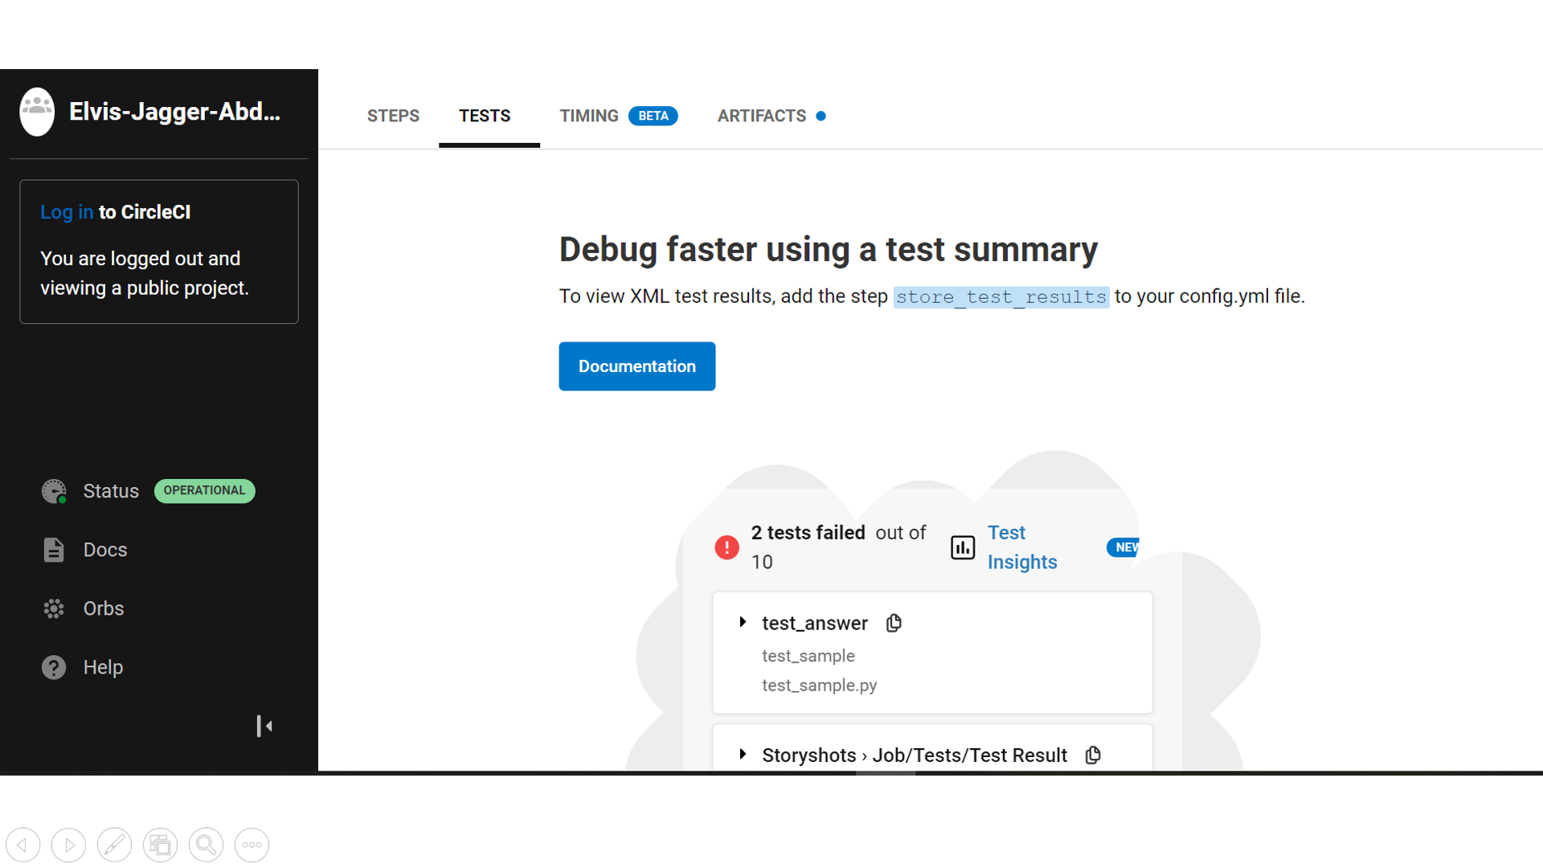

2) Perform an unit test

It is tested the website corresponding to each website unit, and performs a unit test as follows.

* Description: It will be informally carried out for each developer whenever a software unit is completed during coding, which it is tested an executable module.
* Test location: Where developed
* Test organization: Each developer will carry out unit tests for modules responsible for coding.
* Check item

          - Website unit name and composition item identifier

          - Modification history of website units

          - Writer of website units

          - Website unit code

3) Integrated test

* Integrated test activity is to integrate and test components and systems, which develops test cases and data required for the test and performs the integration between components and integrated test between subsystems.
* System test activity is to verify operations of finally implemented codes, which develops test cases and data required for the test and performs the test to satisfy functional and other requirements for the system.

4) Integrated test and test preparation

 It performs to prepare the activity for technical test.

1. Test preparation data (define test data and interface procedures)
2. Install software for test
3. Build test environment

5) Perform integrated test and test

Software/hardware integration and test is performed on H/W to be installed at target troop for technical test.

Figure 4. Final build-test on CircleCI

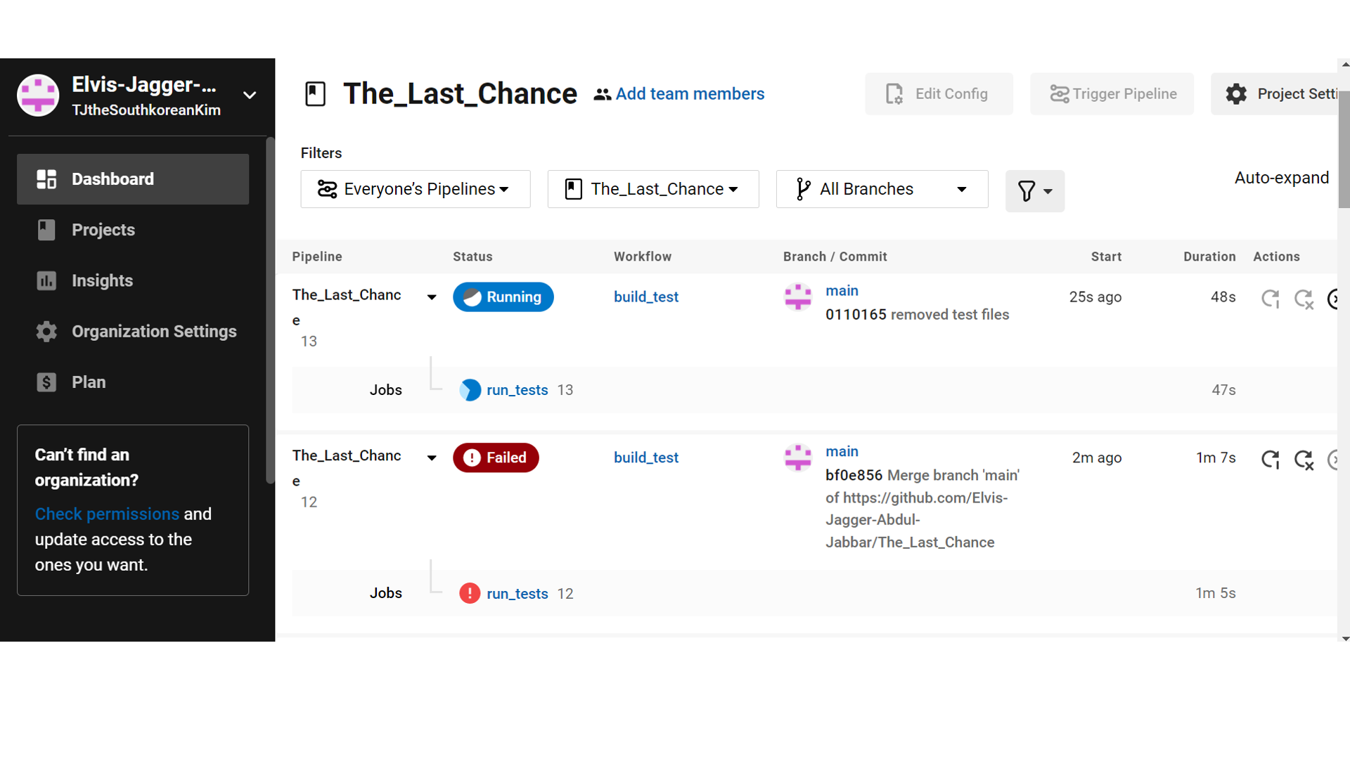

6) Modify, supplement and retest

Website interface related software error occurred during the system integrated test would be recorded and stored in the software development file, and the related software production would be modified if necessary.

7) Analysis and record of integrated tests and test results

Test results and analysed contents would be record and keep in the fault management file.

So, it should be confirmed in the final test whether the following information appears well on the website: test preparation data (define test data and interface procedures)

1. Population by region
2. Multi-national language support
3. The following reports

* Country Report
* City Report
* Capital City Report
* Population Report

□ System Support

1. Operation planning after system implementation

○ The statistics data analysis and customising work are performed for system stabilisation after completing business, perform additional education if necessary, and respond to software-related inquiries.

○ Support to stabilise the website management system interworked with website equipments

○ When a requirement for each subsystem (UI improvement etc.) is occurred, support to improve it through consultation with a person in charge.

**References**

Verzuh, E., & American Psychological Association. (2021). A Guide to the Project Management Body of Knowledge: PMBOK Guide.

Schwalbe, K. (2015). Information technology project management. Cengage Learning.

https://app.circleci.com/pipelines/github/Elvis-Jagger-Abdul-Jabbar/The_Last_Chance?filter=all